Project Design Phase-II
Technology Stack (Architecture & Stack)

Date | 9 March 2026
Team Members | Mansi,Om,Meenakshi,Nitesh
Project Name | Plugging into the Future: An exploration of electricity
Maximum Marks | 4 Marks

Technical Architecture: The Deliverable shall include the architectural diagram as below and the information as per the table1 & table 2

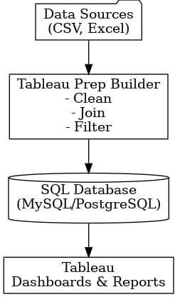

Table-1: Components & Technologies:
S.No | Component | Description | Technology
1 | User Interface | Users interact with dashboard, filters, charts and comparison visuals | HTML, CSS, Bootstrap, JavaScript
2 | Application Logic-1 | Data cleaning, preprocessing, handling missing values | Python (Pandas)
3 | Application Logic-2 | Filtering, state/year selection, comparison logic | Flask (Backend Routing), Pandas
4 | Application Logic-3 | Data aggregation, grouping, KPI generation | Pandas (SUM, GROUPBY, Aggregations)
5 | Visualization Engine | Generation of charts (state-wise, year-wise, sector-wise) | Chart.js / Plotly (or your chart library)
6 | Database | Structured electricity consumption dataset | CSV Dataset (Electricity_Consumption.csv)
7 | File Storage | Storage of raw and cleaned dataset files | Local File System (.csv files)
8 | Export Module | Export dashboard data into downloadable format | Python (CSV Export)
9 | Web Framework | Backend application handling requests and responses | Flask (Python Framework)
10 | Data Processing Layer | Conversion of processed data into visualization-ready format | Python (JSON conversion via Flask)
11 | Infrastructure (Server / Hosting) | Deployment and hosting of web dashboard | Localhost / Cloud Deployment (if hosted)
Table-2: Application Characteristics:
S.No | Characteristics | Description | Technology
1 | Open-Source Frameworks | Open-source libraries used for backend processing and visualization | Python, Flask, Pandas, Chart.js / Plotly
2 | Security Implementations | Basic application-level protection and controlled dataset modification (Admin-level access) | Flask Routing, Server-side Validation
3 | Scalable Architecture | Separation of Presentation Layer, Application Layer, and Data Layer (3-Tier Architecture) | Flask 3-Tier Architecture
4 | Availability | Web-based dashboard accessible through browser when server is running | Flask Web Server (Localhost / Cloud)
5 | Performance | Optimized data filtering and aggregation for faster dashboard updates | Pandas Aggregations, Efficient CSV Handling
6 | Maintainability | Modular structure separating routes, templates, and data processing logic | Flask MVC Structure
7 | Reliability | Accurate data display using validated and cleaned dataset | Pandas Data Cleaning & Validation

